GOVERNMENT OF THE DISTRICT OF COLUMBIA
OFFICE OF THE ATTORNEY GENERAL
oag.dc.gov

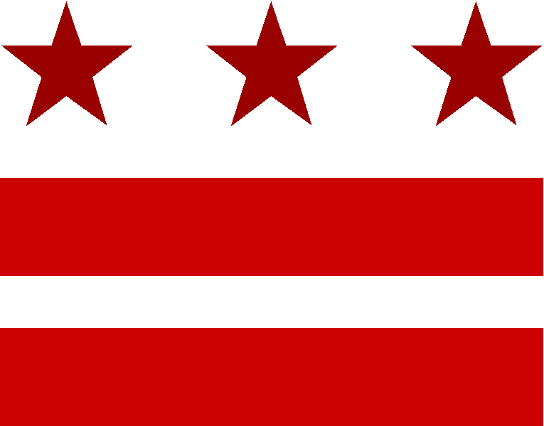

January 28, 2015
FOR IMMEDIATE RELEASE
CONTACT:
Ted Gest
Public Information Officer
202-727-6283
ted.gest@dc.gov
14 RUFF FELLOWS JOINING D.C. ATTORNEY GENERAL’S OFFICE

WASHINGTON, D.C. – Fourteen Charles (Chuck) F.C. Ruff Fellows, graduates of George Washington University Law School, Georgetown University Law Center, UDC David A. Clarke School of Law, American University Washington School of Law, and Howard University School of Law, are beginning work at Office of the Attorney General for the District of Columbia (OAG).

The fellows are being funded jointly by the schools and OAG. They were chosen by the schools and the Attorney General’s Office in a competition among top graduates from each school. They will work in several different Divisions of the office for a year.
Three previous classes totaling 43 Ruff Fellows worked at OAG during the last three years. Several of them were hired for permanent positions in the office.
The new Fellows and their assignments to OAG divisions are, from George Washington, William J. Chang, Civil Litigation Division; W. Lawrence Ferris III, Commercial Division; Patrick Galasso, Public Safety Division; Kevin J. Healy, Public Interest Division; Mary Shields, Legal Counsel Division; and Milena Mikailova, Personnel, Labor and Employment Division; from Georgetown, Philip Cheney, Public Interest Division; Emily Stewart, Family Services Division; Matthew Trout, Public Interest Division; Owen Williams, Civil Litigation Division, and Stacy Jeremiah, who will be serving a second year in the Public Safety Division; from UDC David A. Clarke School of Law, Pegah Eftekhari, Public Interest Division; from American University, Elizabeth M. Bookwalter, Public Interest Division; and from Howard, Bianca P. Goodman, Office of the Solicitor General.
The Fellowships were created to provide the District government with more legal assistance and to promote public interest legal work. They are named in honor of Charles F.C. Ruff, who was the District of Columbia Corporation Counsel (the position now known as Attorney General) from 1995 to 1997. Ruff also served as the U.S. Attorney for the District of Columbia and taught at area law schools. Ruff, who passed away in 2000, was White House Counsel to President Bill Clinton after his service as Corporation Counsel.
Attorney General Karl A. Racine said, “We are pleased that Howard University School of Law has joined our partnership program with four other D.C. law schools to provide legal services for the District and good experience for their recent graduates. We have now had three classes of exceptional Ruff Fellows contribute their expertise to our work on behalf of the District. We look forward to more outstanding work from this new class of top law school graduates.”

